8．触发器

1. 触发器：trigger



1. 创建触发器：
2. 创建**只有一个执行语句**的触发器：



CREATE TRIGGER trig_tbook AFTER INSERT ON t_book FOR EACH ROW

UPDATE t_booktype SET bookNum = bookNum + 1 WHERE new.bookTypeId = id

INSERT INTO t_book VALUES(NULL,'java好难',23,'老舍',2)

1. 创建**有多个执行语句**的触发器：

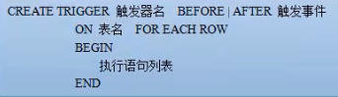

DELIMITER |

CREATE TRIGGER trig_book2 AFTER DELETE

ON t_book FOR EACH ROW

BEGIN

UPDATE t_bookType SET bookNum=bookNum-1 WHERE old.bookTypeId=t_booktype.id;

INSERT INTO t_log VALUES(NULL,NOW(),'在book表里删除了一条数据');

DELETE FROM t_test WHERE old.bookTypeId=t_test.id;

END

|

DELIMITER ;

1. 查看触发器：



SHOW TRIGGERS;

1. 删除触发器：

